King George V Maths Subject Policy
Intent:
Mathematics is a creative and highly inter-connected discipline that has been developed over centuries, providing the solution to some of history’s most intriguing problems. It is essential to everyday life, critical to science, technology and engineering, and necessary for financial literacy and most forms of employment. A high-quality mathematics education therefore provides a foundation for understanding the world, the ability to reason mathematically, an appreciation of the beauty and power of mathematics, and a sense of enjoyment and curiosity about the subject.

At King George V Primary, we follow the National Curriculum for Mathematics which aims to ensure that all pupils:
- Become fluent in the fundamentals of mathematics, including through varied and frequent practice with increasingly complex problems over time, so that pupils develop conceptual understanding and the ability to recall and apply knowledge rapidly and accurately.
- Reason mathematically by following a line of enquiry, conjecturing relationships and generalisations, and developing an argument, justification or proof using mathematical language
- Can solve problems by applying their mathematics to a variety of routine and non-routine problems with increasing sophistication, including breaking down problems into a series of simpler steps and persevering in seeking solutions.

Implementation:
We recognise that pupils need to learn basic number facts and acquire fluency in procedures, alongside developing conceptual understanding if they are to be able to solve increasingly complex problems in life and later in the workplace.

We adopt a mastery approach to teaching mathematics. Teaching for mastery is underpinned by the ‘five big ideas’ of mastery, as outlined below:

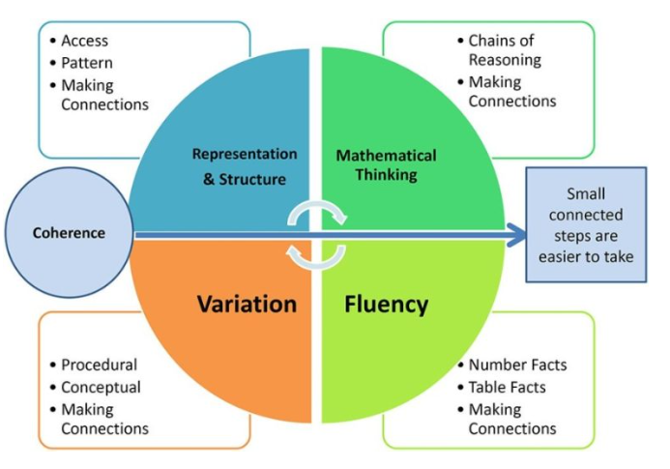

Coherence
Lessons are broken down into small connected steps that gradually unfold the concept, providing access for all children and leading to a generalisation of the concept and the ability to apply the concept to a range of contexts.
Representation and Structure
Representations (concrete, pictorial, abstract) used in lessons expose the concepts and mathematical structure being taught, the aim being that students can do the maths without recourse to the representation.
Mathematical Thinking
If taught ideas are to be understood deeply, they must not merely be passively received but must be worked on by the student: thought about, reasoned with and discussed with others.
Fluency
Quick and efficient recall of facts and procedures and the flexibility to move between different contexts and representations of mathematics.
Variation
Variation is twofold. It is firstly about how the teacher represents the concept being taught, often in more than one way, to draw attention to critical aspects, and to develop deep and holistic understanding. It is also about the sequencing of the episodes, activities and exercises used within a lesson and follow up practice, paying attention to what is kept the same and what changes, to connect the mathematics and draw attention to mathematical relationships and structure.

High expectations of all pupils
The mastery approach ensures that we have high expectations of all our pupils. We endeavour to make the mathematics curriculum accessible to all pupils; moving them through the programme of study at broadly the same pace, with scaffolds to support pupils struggling to master key concepts and opportunities to work on the objectives more deeply for those who rapidly grasp concepts. All children need a deep understanding of the mathematics they are learning in order that future learning is built upon firm foundations.

Impact:
- Assessment of children's learning in Maths is an ongoing monitoring of children's understanding, knowledge and skills by the class teacher, throughout lessons. This assessment is then used to inform the level of scaffold and challenge required by the children.
- Summative assessment is conducted termly by class teachers across each year group of the school to inform the subject leader of progress or skills and knowledge still to be embedded.
- Maths in school is also monitored by the subject leader throughout the year in the form of book monitoring, looking at outcomes and discussions with pupils about their learning and understanding and establish the impact of the teaching taking place.
- In EYFS, Maths statements have been taken from ‘Development Matters’ and broken down into termly milestones. Children are assessed according to these statements and recorded as ‘on track or working towards’. ‘Wow moments’ and observations are collected as evidence towards the children achieving against expected milestones.

